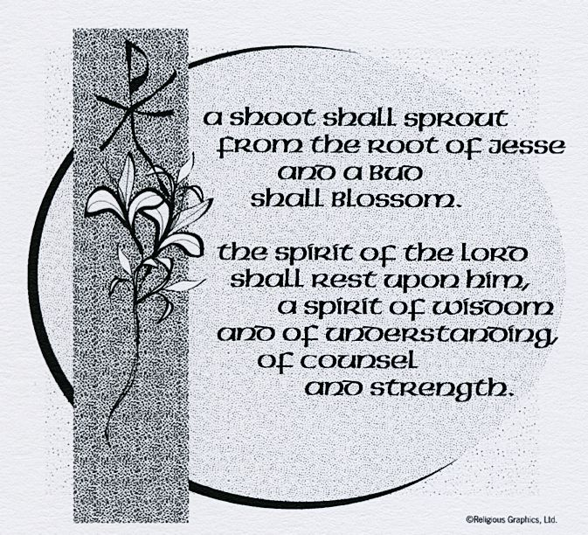
ST. ROSE CHURCH St. Rose, IIlinois
Fr. Edward F. Schaefer
18010 St. Rose Road
526-4118 Rectory

SUNDAY MASS 10:00AM
SAT. VIGIL MASS 4:00PM
WEEKDAY MASS 7:45AM
RECONCILIATION Saturday: 3:15 – 3:45PM
WEBPAGE: www.strosechurchil.com
EMAIL: belpsros@outlook.com
FACEBOOK: St. Rose Catholic Church – St. Rose, IL

MASS WILL BE LIVE STREAMED ON OUR FACEBOOK PAGE SATURDAYS AT 4PM

SUNDAY COLLECTIONS: Weekly Envelopes: $2,592.00
CCHD: $20.00 Capital Improvement Fund: $ 235.00
Sister Parish: $95.00 Thanksgiving: $ 975.00

INTENTIONS: MASS
Mon 7:45AM Advent Weekday No Mass
Tue 7:45AM St. Nicholas No Mass
Wed 6:00PM Vigil Immaculate Conception of The Blessed Virgin Mary Jo Ann Vonder Haar
“ “ “ “ “ Cletus Henrichs
“ “ “ “ “ Annie & Augie Timmermann
Thu 7:45AM Immaculate Conception of The Blessed Virgin Mary No Mass
Fri 7:45AM Advent Weekday No Mass
Sat 4:00PM Vigil Third Sunday of Advent William & FloriannTimmermann
“ “ “ “ L/D William & Bertha Thole Family
“ “ “ “ L/D Robert Koerkenmeier Family Sun 10:00AM Third Sunday of Advent For the Parish

SERVERS: Sat 4PM Loralie & Tinsley Schwierjohn, Kayley Burian & Mandy Poettker
Sun 10AM Lukas Winkeler, Bella Thole, Addison Thole, Cole Timmermann

READERS: Sat, 4PM: Peggy Thole Sun 10AM: Terry Kampwerth
EUCHARISTIC MINISTERS: Sat 4PM Jean Tebbe Sun 10AM: Paul Meyer
OFFERTORY: Wed 6:PM Vonder Harr, Henrichs & Timmerman families
Sat 4PM: Timmermann, Thole & Koerkenmeier families
Sun 10AM: Jeff & Susan McCray
VOCATION CUP: The next person to receive the Vocation Cup Ralph Thole.
WELCOME: Please welcome Fr. Carl Scherrer who will be having this weekend’s Masses and Fr. Dan Friedman who will be having the Wednesday night 6PM Mass..
UPDATE: Please continue to keep Fr. Ed in your prayers as he recovers. If you would like to send Fr. Ed well wishes, please drop it in the collection basket or send to Hincke Home, 2620 Lebanon Ave, Belleville, IL 62221. He continues to make progress in his healing and strength.

“HAVE YOU REMEMBERED ST. ROSE PARISH IN YOUR ESTATE PLANNING?”

PLEASE NOTE: Thursday, Dec 8th is the feast of the Immaculate Conception of the Blessed Virgin Mary. There will be no Mass that day. There will be a Vigil Mass on Wednesday, Dec. 7th at 6:00PM.
SYMPATHY: Our sympathy to the family of Beatrice “Bea” Tebbe. Bea, who passed away recently, was the mother of Daniel (Sandy) Tebbe, Donald (Karen) Tebbe, Dave (Connie) Tebbe and
Mark (Nancy) Tebbe. She was the grandmother of Matthew (Leanna) Tebbe, Paige (John) Kalmer,
Alex (friend, Ana Trabanino) Tebbe, John (Renee) Tebbe, Katie (friend, Jason Kell) Tebbe. She was the great grandmother of John & Krue Kalmer. May Bea enjoy the reward of eternal life.
SYMPATHY: Our sympathy to the family of Robert “Bob” Fischer. Bob who passed away recently, was the brother of Lidwina Schumacher and brother-in-law of Mary Lou Fischer.
May Bob enjoy the reward of eternal life.
CONGRATS: October Wildcats: Nolan Robke, Addie Rodgers, Wade Stock and Kelli Poettker.
CONGRATS: Korbin Burian and Alyssa Koerkenmeier who were named Mater Dei Student of the week.
ST. ROSE SCHOOL WINTER CONCERT: Thursday, Dec 8th at 7PM
HAPPY ANNIVERSARY: Dec 5 Tyler & Carrie Kramer ‘09
HAPPY BIRTHDAY:
Dec 04 Lane Tebbe 9 Dec 06 Heather Thole Dec 09 Zane Tebbe 9
Dec 05 Owen Faust Dec 07 Amber Poettker Dec 10 Samantha Faust 20
Dec 05 Madison Timmermann Dec 07 Bill Rauen Dec 10 Donald Fuhler
Dec 06 Thomas Altgilbers Dec 08 Jessica Fuhler Dec 10 Landon Hilmes 11
Dec 06 Terry Snyder Dec 08 Mary Lou Voss Dec 10 Danielle Voss
VOCATIONS CORNER: “The priestly vocation is essentially a call to sanctity, in the form that derives from the
Sacrament of Holy Orders. Sanctity is intimacy with God: It is the imitation of Christ, poor, chaste & humble; it is unreserved love for souls and self-giving to their true good; it is love for the Church which is holy and wants us to
be holy, because such is the mission that Christ has entrusted to it. Each one of you must be holy also in order to
help your brothers pursue their vocation to sanctity.” St.John Paul II
FAITH AND POVERTY: A GLOBAL RESPONSE:
Do you ever DREAM of a world without hunger or poverty? Would you seriously like to make this world a reality? Please join us for a life changing course on ‘FAITH AND POVERTY: A GLOBAL RESPOSE.”
This course will meet at Mater Dei High School for 8 sessions on the first & third Thursdays of each month beginning Thursday, Jan. 5th from7-9PM. For questions or to join us, call Helen Essenpreis
618-980-1875, Fran Etter 618-971-8886 or Myrt Rollins 314-707-7063.
ADVENT RECONCILIATION:
St. Mary Carlyle on Sunday, Dec. 4th at 3PM Dec 11 St. Bernard, Albers 1PM
Dec 11 St. Francis, Aviston 3PM
CHURCH PARKING: If you are dropping off someone at the North entrance to church, and you
have no trouble walking, please park in the regular parking spaces and allow those who do have
trouble walking but are still driving to park in the 5 spaces closest to the North door. THANK YOU!
ATTENTION READERS: The new Lector Workbooks are located on the south porch of the rectory and are ready for pick up. Thank You!
AN URGENT NEED THIS CHRISTMAS: If you are in the giving mood and cannot shop for the local families, perhaps you can pick one of the Catholic Relief Services Giving Tree Monetary Gifts. Because of the hunger crisis in East Africa, 1.4 million children under the age of 5 face acute malnutrition by this December. Nearly 330,000 are at risk of dying without immediate aid. Gift tags are available at the Church entrances. Please be generous. Make checks payable to Catholic Relief Services & drop in the collection basket.
CELEBRATE CHRISTMAS JOY WITH THE HEARTLAND COMMUNITY CHORUS!
Concerts are Sat., Dec 10th 7:30PM and Sun., Dec 11th 3PM a St. Paul Church, 1411 Main St., Highland.
A brass quintet, flute and percussion will join forces with the singers for a festive program! Tickets are $15
available from any chorus member, at the door or online at heartlandcommunitychorus.org.
(16 and under free)

