St. Felicitas Church
13322 Church Road
Carlyle, IL 62231
Phone: 594-3040 Fax: 594-3040
stfelbp@wisperhome.com

Father Ed Schaefer
belpsros@outlook.com
Cell: 618-526-4118

Father Tom Killeen

Parish Pastoral Council: Justin Benhoff, Gene Bickl, Cindy Gnaedinger, Joe Luebbers
Finance Council: Mary Huelsmann, John Ketterer, Dan Potthast, Allen Thole and Margie McQuade.
Parish Trustees: Barry Hampel and Alan Heldorfer
Administrative Asst: Deb Rakers 618-698-9141 or 618-594-3040

Twenty-sixth Sunday in Ordinary Time
We gather today to listen to God’s word and to share in the Eucharist. In today’s first reading we hear the story of two of Moses’s friends. Eldad and Medad, who missed the gathering when the Lord bestowed the spirit of prophesy on all the elders. Yet the spirit of the Lord came to rest on them as well. Let us keep in mind all those who are not with us today, for whatever reason, and pray that the Holy Spirit may bear fruit in them as well as all of us.
Joshua stands ready to condemn those who prophesy without God’s authority, but Moses praises God’s generous gift of the spirit, no manner on whom it might come to rest. Jesus similarly tells John that anyone doing mighty deeds in his name should be welcomed. May the Holy Spirit bestowed on us in baptism, lead us to speak and do great things.

Question of the week:
What aspect of my selfhood leads me to sin? What must I do to remove that aspect?
Taken from Pastoral Patterns

St. Teresa, Marydale will have there chicken dinner today, Sept. 26 from 11 a.m. until 4 p.m. or until they are sold out so please support them if you are able.

WEEKLY OFFERING
9-18-2021
Number of Envelope
Envelopes Total $.00
Loose Collection $.00
Grand Total. $.00

Our monthly income for August 2021 was $6424.00 our monthly expenses totaled $9074.00. Please give as you are able.

Thank you for your generosity!

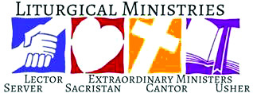

September 26: 9:30am
LECTORS: Alayna Benhoff
MINISTERS OF HOLY COMMUNION: Jackie Albers
GIFT BEARERS: Arlene Hilmes family
SERVERS: Connor, Maecie, Cara, Evie & Maggie
MUSICIAN: Lisa McQuade

October 3: 9:30 am
LECTORS: Sue Potthast
MINISTERS OF HOLY COMMUNION: Lisa Voss
GIFT BEARERS: Potthast or Hampel family
SERVERS: Abby, Alex, Aiden, Avery, Zoey
MUSICIAN: Lisa McQuade

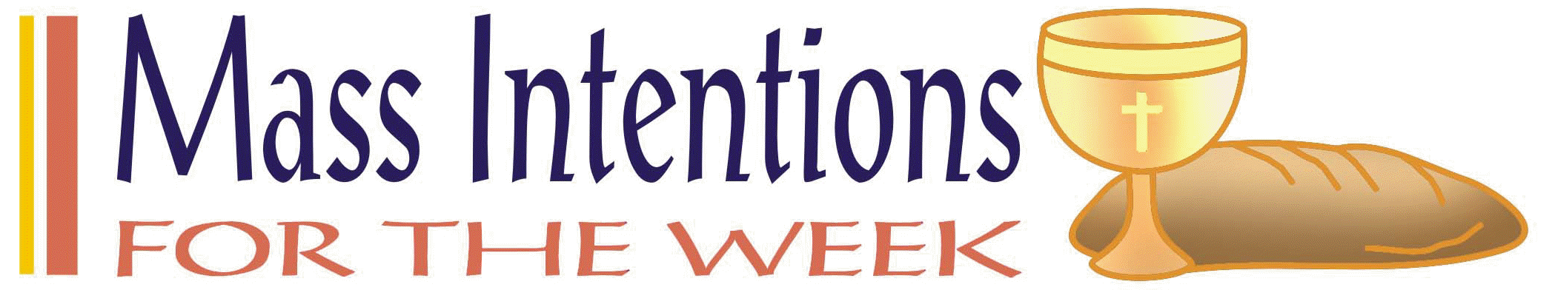

September 26: Greg & Mike Hilmes and Barb Voss

October 3: Betty Potthast

This Photo by Unknown Author is licensed under CC BY-SA

Justin Hilmes – September 26

Lester Peppenhorst – September 28

Martha Solis – October 2

Don and Cindy Marti – October 2 – 40 years.

If you would like to be recognized for your birthday or anniversary in the weekly bulletin, please mark your special day in the calendar in the back of church
____________________________

VOCATION CORNER

September 26 – “After working in corporate America for 10 years and earning three degrees, I realized that everything the world said would make me happy wasn’t fulfilling my deepest desires. If anything, these accomplishments left me emptier and more anxious. I had never thought about being a priest, but I remember reading an article that mentioned three hurdles to discerning a religious vocation – noise, fear, and family. Through prayer and reading Scripture, it became clear that he was calling me to be a priest. However, I still struggled with fear and feelings of inadequacy, and my family, though Catholic, didn’t understand why I would leave my worldly achievements behind. With God’s grace, I was able to persevere and follow the Lord” Columbus Magazine July 2021

St. Andrew Dinner: Bishop McGovern and the Vocations Office staff cordially invite young men of high school

Sept. 21-Vendor Fair St. George Community Life Center, New Baden, 10 a.m. – 2 p.m. Sponsored by the St. George Family Life & Social Activities Committee.
Sept. 26-St. Teresa Church Marydale Chicken Dinner-drive thru-11 a.m. – 4 p.m. or until sold out. $12.00 per meal
Oct. 3-St. Dominic Church, Breese – Chicken Dinner, carry out only from 11 a.m. – 5 p.m. $12.00 per dinner -flyer on bulletin board.
Oct. 10-Aviston American Legion, Aviston , Pork Sauage & Roast Beef dinner from 10:30 a.m. – 6 p.m. Carry out only with limited dining space available. Also, the Auxiliary is hosting Holiday (Halloween, Thanksgiving, Christmas only) rummage sale the same day from 10 a.m. – 5 p.m. (brown bag at 3 p.m.)

We have a date set for October 4 for pictures to be taken for the directory. Everyone who has their picture taken will receive an 8x10 photo and a directory free of charge. Scheduling can be done online or with Deb after Mass. There are still many dates available, and we have the next day if we need it to schedule more times. Please consider having your picture take for the directory. You may take your own picture and submit for the directory, but it will cost $15.00. Please schedule your time or submit your picture as soon as possible so we may finalize everything.

____________________________________________

National Shrine of Our Lady of the Snows Way of Lights Volunteer Request, Friday November 19th - Friday, December 31st. Looking for a special way to share the holiday spirit? Volunteer for a shift or two during the Way of Light greeting visitors to the Christmas tree display or helping at the Oblates Exhibit area at the Shrine of Our Lady of the Snows from 11-19 thru 12-31. \This is also a great opportunity for youth service hours. If interested, please email programs@snows.org or call 618-394-6281 snows.org/wol
____________________________________________________

- With whom will I stand in faith?
- How will I keep my eyes fixed on Jesus this day?
Fliers for the upcoming chicken dinner, which is, are available in the back of church.
Please take some and help spread the word.
Worklist and raffle tickets are also available,
please pick up your copy to help save with postage cost.
Also, please start saving your empty ice cream,
margarine, etc containers to use for leftover food.

Please pray for those who need the Lord’s healing in body, mind or spirit, especially Florence Huelsmann, Margie McQuade, Ramona Haislar, Taylor Marti, Gerald Hilmes, Ken Wellen,, Jim Jansen, Jerome Jansen, Gene Bickl, Ed McQuade, Wolters families and all who asked for our prayers.

Please Update your contact information
Are your records current? Have you dropped your landline or changed your cell number? Have you moved, been married, divorced or had a baby? Please help us keep our records accurate. Please check the folder on the back table and let us know at the parish office by emailing: stfelicitasbeaverprairie@gmail.com.

Please Update your contact information
Are your records current? Have you dropped your landline or changed your cell number? Have you moved, been married, divorced or had a baby? Please help us keep our records accurate. Please check the folder on the back table and let us know at the parish office by emailing: stfelbp@wisperhome.com.

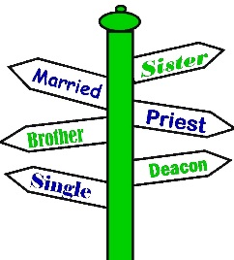

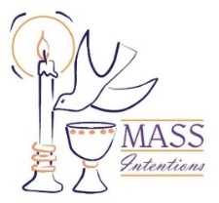
We welcome request for Mass Intentions
You can remember someone who has died recently or many years ago. But the intentions do not have to be just for the dead. They make beautiful gifts for any special occasion: birthdays, anniversaries, or even in thanksgiving. Mass intentions can be made by contacting the parish office or you may drop the following form along with payment in an envelope mark “Mass Intention” in the collection basket. Intentions are $10 per mass.
Available upcoming dates: Sept. 29; Oct. 6, 13 & 27

For: ___________________________________
Date requested: __________________________
Requested by: ___________________________
Phone Number: __________________________
If you have something you would like posted in the bulletin, please have it to the church office by Wednesday evening
via email to: stfelbp@wisperhome.com
or test Lisa by noon on Thursday

.

FATHER BRETT

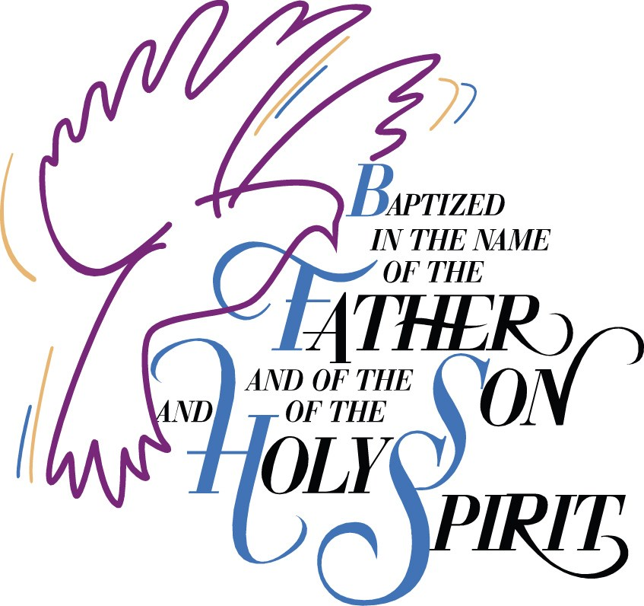

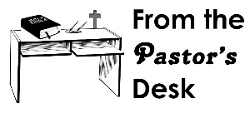

September 5: 9:30am
LECTORS: Millie Peppenhorst
MINISTERS OF HOLY COMMUNION: Lisa Voss
GIFT BEARERS: Monken’s family
SERVERS: Abby, Alex, Alayna, Mariah & Makenna
MUSICIAN: Lisa McQuade

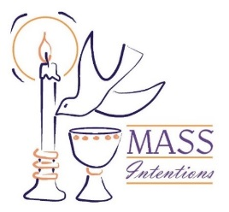
We welcome request for Mass Intentions
You can remember someone who has died recently or many years ago. But the intentions do not have to be just for the dead. They make beautiful gifts for any special occasion: birthdays, anniversaries, or even in thanksgiving. Mass intentions can be made by contacting the parish office or you may drop the following form along with payment in an envelope mark “Mass Intention” in the collection basket. Intentions are $10 per mass.

For: ___________________________________
Date requested: __________________________
Requested by: ___________________________
Phone Number: __________________________

