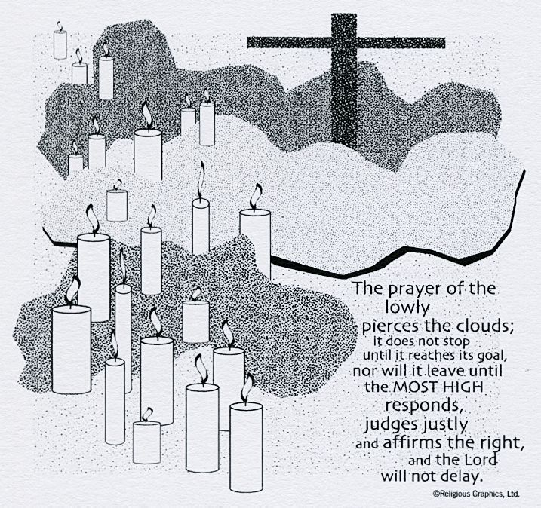
ST. ROSE CHURCH St. Rose, IIlinois
Fr. Edward F. Schaefer
18010 St. Rose Road
526-4118 Rectory

SUNDAY MASS 10:00AM
SAT. VIGIL MASS 4:00PM
WEEKDAY MASS 7:45AM
RECONCILIATION Saturday: 3:15 – 3:45PM
WEBPAGE: www.strosechurchil.com
EMAIL: belpsros@outlook.com
FACEBOOK: St. Rose Catholic Church – St. Rose, IL

MASS WILL BE LIVE STREAMED ON OUR FACEBOOK PAGE SATURDAYS AT 4PM

SUNDAY COLLECTIONS: Weekly Envelopes: $2,229.00
Capital Improvement Fund: $ 545.00
Sister Parish: $ 150.00

INTENTIONS: MASS
Mon 7:45AM Weekday No Mass
Tue 7:45AM Weekday No Mass
Wed 7:45AM Weekday No Mass
Thu 7:45AM Weekday No Mass
Fri 7:45AM Sts Simon & Jude No Mass
Sat 4:00PM Vigil: Thirty-First Sunday in Ordinary Time John & Martha Henrichs
“ “ “ “ Marie Detmer
“ “ “ “ In Thanksgiving Popeye & Ag Korte
Sun 10:00AM Thirty-First Sunday in Ordinary Time For the Parish

SERVERS: Sat 4PM Alaina Schrage, Grayce & Jacob Sturgeon, Kaylee Burian
Sun 10AM Ava Sidwell, Lucas Winkeler, Addison Tebbe, Brianna Tebbe

READERS: Sat 4PM Mary Lou Voss Sun 10AM: Pete Jansen
EUCHARISTIC MINISTERS: Sat 4PM Mary Jean Harper Sun 10AM: Ralph Bruggemann
OFFERTORY: Sat 4PM: Popeye & Ag Korte Family Sun 10AM: Jay & Marilyn Fuhler

VOCATION CUP: The next family to receive the Vocation Cup is the Larry Thole family.

WELCOME: Please welcome back Fr. Carl Sherrer who will be having the Masses this weekend.
UPDATE: Please continue to keep Fr. Ed in your prayers as he recovers. If you would like to send Fr. Ed well wishes, please drop it in the collection basket or send to Hincke Home, 2620 Lebanon Ave, Belleville, IL 62221. He continues to make progress in his healing and strength.
YOUNG ADULT CATHOLIC GATHERING: Bishop McGovern would like to invite Young Adult Catholics ages 18-35 to join him for an afternoon of prayer at the Poor Clare Monastery in Belleville on Sunday,
Oct 30th at 3PM for Adoration, the Rosary, Benediction & fellowship. RSVP by Oct 26 to Judy Hoffmann jhoffmann@diobelle.org or call 618-722-5003

“HAVE YOU REMEMBERED ST. ROSE PARISH IN YOUR ESTATE PLANNING?”

ST. ROSE FALL QUILT BINGO
SUNDAY, NOVEMBER 6TH IN THE GYM
DOORS OPEN AT 5PM AND BINGO STARTS AT 6:30PM
RAFFLE TICKETS LOCATED AT THE BACK OF CHURCH $1 EACH OR 6 FOR $5

SYMPATHY: Our sympathy to the family of Paul Voss. Paul, who passed away recently, was the
brother of Virgil (Mary Lou) Voss, the uncle of Rebecca (Dave) Boeschen and Ben (Nancy) Voss.
He was also the great-uncle of Grace Boeschen. May Paul enjoy the reward of eternal life.
CONGRATULATIONS: To Courtney (Trame) and Justin Detmer who were married here last weekend.
Many blessings to them!

HAPPY ANNIVERSARY:
Oct 24 Norbert & Marilyn Thole ’75 Oct 26 David & Melinda Thole ‘84
Oct 27 Craig & Brooke Mollet ’12 Oct 29 John & Paige Kalmer ‘16
Oct 29 Popeye & Ag Korte ’52 Oct 29 Theodore, Jr. & Dolores Richter ‘71
Oct 29 Allen & Rose Strieker ’66 Oct 29 Andrew & Judy Tebbe ‘88
Oct 30 William & Sandra Timmermann ’82 Oct 31 Karl & Emily Stock ‘09
HAPPY ANNIVERSARY: To Popeye & Ag Korte who are celebrating 70 years of marriage!
HAPPY BIRTHDAY:
Oct 24 William Meyer 15 Oct 26 Gary Vonder Haar Oct 30 Elvira Tebbe
Oct 25 Jeannie Frohn Oct 26 Farrah Voss 8 Oct 31 Tami Poettker
Oct 25 Stacey Meyer Oct 27 Larry Goebel Oct 31 Wade Stock 6
Oct 25 Lyndsey Richter 19 Oct 28 Emily Stock Oct 31 Kevin Thole
Oct 25 Janice Winkeler Oct 29 Dolores Richter
Oct 26 Jessie Poettker 5 Oct 29 Rob Sidwell

VOCATIONS CORNER: “Wherever God has put you, that is your vocation. It is not what we do but how much love we put into it.” St. Mother Teresa of Calcutta
ST. THERESA CHURCH, SALEM, FALL HARVEST DINNER: Sunday, Oct 23rd in the gym at 109 Ohio St., Salem from 11AM to 1PM.Pork Loin Roast, mashed potatoes & gravy, green beans, corn, cranberry sauce, coleslaw, dessert & drink. Adults $126-12 $6 and children under 6 eat free. Carry outs available.
ST. DOMINIC CHURCH, BREESE RUMMAGE & BAKE SALE:Thursday, Oct 27 5PM to 9PM, Friday, Oct 28 9AM to 8PM Saturday, Oct 29 9AM to 3PM Sunday, Oct 30 9AM to 1PM. Lunch available all four days. See bulletin board for more information.
BREESE KNIGHTS OF COLUMBUS PANCAKE BREAKFAST & TRUNK OR TREAT: Sunday, Oct 30 at the KC Hall from 8AM to 1:30PM. See bulletin board for more information.
JOURNEY TO JUSTICE RETREAT: Catholic reflections on our call to address racial inequity. Saturday, Nov 5th from 9AM to 3PM at Our Lady of the Snows. $15 & includes lunch & continental breakfast at 8:30AM. For more information, see bulletin board or register at
snows.org/journey-to-justice-retreat.
GIBAULT CATHOLIC HIGH SCHOOL, WATERLOO SEEKIG HIGH SCHOOL PRINCIPAL:
More information on bulletin board or email jbirdsong@diobelle.org.
LOVE TO READ? ENJOY HISTORY?: The Adorers of the Blood of Christ, who served this parish for many years, have books available to tell the history of their coming to the USA in the 1870’s. If you’d like a copy of JOY IN THE PLANTING, or the story of their foundress in OBEDIENT REBEL, please take a copy (free). They are available in the entrance of church. Happy reading!!!

