St. Felicitas Church
PRAYER REQUEST

Please pray for those who need the Lord healing in body, mind or spirit, especially Florence Huelsmann, Margie McQuade, Taylor Marti, Gerald Hilmes, Ken Wellen,
Jim Jansen, Ed McQuade, Kathy Gress, Sr. Diane, Father Ed Schaefer, Jonathan Hoskins, Jeff Burnett, Irene Schutz and all who asked for our prayers.

and all who asked for our prayers.
Fr. Dale Maxfield, and all who asked for our prayers.

13322 Church Road
Carlyle, IL 62231
Phone: 594-3040 Fax: 594-3040
stfelbp@wisperhome.com

Father Ed Schaefer
belpsros@outlook.com
Cell: 618-526-4118

Father Tom Killeen

Parish Pastoral Council: Justin Benhoff, Gene Bickl, Cindy Gnaedinger, Joe Luebbers
Finance Council: Mary Huelsmann, John Ketterer, Dan Potthast, Allen Thole and Margie McQuade.
Parish Trustees: Barry Hampel and Alan Heldorfer
Administrative Asst: Deb Rakers 618-698-9141 or 618-594-3040

Second Sunday of Lent
Today on our journey through this penitential season we are reminded of the promise the Lord makes to us. God asked Abraham to look up to the heavens and witness the uncountable stars in the sky. Peter, John, and James looked up to the heavens and saw Jesus transfigured to shine like the sun. As we fast, pray, and give alms this Lent, let us pause to look up to the heavens and consider the incredible vastness of the transformation of us and our world that God set in motion.
God made a covenant with Abraham, promising descendants as numerous as the stars and a jhome as vast as they could imagine. As wonderful as the Promise Land was, Paul teaches the Philippians that God promises us that our citizenship is in heaven, where our glorified Lord awaits. Luke reports that Peter, John, and James were able to see Jesus in glory with Moses and Elijah, dazzling on the mountaintop. May these stories open our eyes to God’s great glory and generosity.

Question of the Week
What change do I need to make in my life to be transfigured to a new self, one who more closely follows the Lord?
_________________________________

Knights of Columbus Meeting – Mar. 15th at 7:30 p.m. at Albers/Damiansville Albers JC Building.

WEEKLY OFFERING

03-06-22
Envelopes 33
Envelopes Total……………$1300.00
Lose Collection………………$219.00
Grand Total………… …….$1519.00
Building & Ground………..$785.00
Eastern Europe……………..$105.00
Black & Indian Mission….$186.00

Our monthly income for February 2022 was $4605.00 and our monthly expenses totaled $13,326.00. (Mater Dei assessment was $6278.00)
Please give as you are able.

Thank you for your generosity!

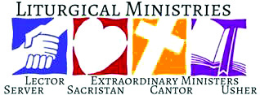
March 13 9:30 a.m.
LECTOR: Alayna Benhoff
MINISTER OF HOLY COMMUNION: Joe Luebbers
GIFT BEARERS: volunteers
SERVERS: PSR class
USHERS: Alvin Huels & Craig Diekemper
MUSCIAN: Lisa Mcquade
March 20: 9:30 a.m.
LECTOR: Sue Potthast
MINISTER OF HOLY COMMUNION: Cindy Gnaedinger
GIFT BEARERS: volunteers
SERVERS: PSR class
USHERS: Dan Ketterer & Dan Potthast
MUSCIAN: Maribeth Detmer

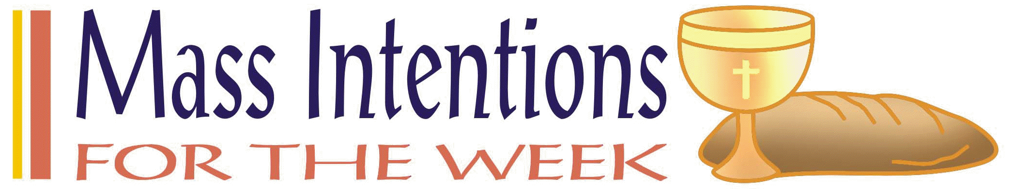

March 13:

March 20:

This Photo by Unknown Author is licensed under CC BY-NC-ND
Steve Gnaedinger – March 15
Mary Huels – March 17

VOCATION CORNERS
March 13: This week is the feast of St. Joseph, “When Joseph awoke, he did as the angel of the Lord had commanded him,” (Matt 1:24) “It was grace that moved Joseph to embrace his vocation as the guardian oif Israel’s Messiah. It's the same grace that empowers us to accept God’s call and wisdom for our lives. Joseph’s yes in faith changed the world. God also has a plan for your life. You don’t know where your yes might lead and how God might use it. Ask Joseph to help. Then, like Joseph, go out in faith to be a “doer of the word” (James 1:2d2d). (The Word Among Us)
_____________________________________

Food for Families Program will be held this Lenten season with a list of items to be donated and where to deliver on the bulletin board if you are able to participate.
_____________________________________

EASTER SCHEDULE: Holy Thursday and Holy Saturday will be at Marydale at 7:30 p.m. and Good Friday will be here at our Church at 7:30 p.m. On Easter, Sunday Mass schedule will be the normal Mass time at both parishes

Job Opportunities – see bulletin board

Seasonal Groundkeeper for the Diocese of Belleville. Deadline Mar. 15th.

Director of Worship thru the Diocese of Belleville. Deadline Mar. 25th.

St. Mary’s Carlyle needs a part-time organist.

Special Events – see bulletin board for additional information.

St Cecilia School is sponsoring a Pork Sausage Dinner today, March 13th in the Cafeteria to benefit the Fire Department.

Golden Egg Raffle at sponsored by St. Dominic Church. Grand prize $20,000.00.
(8 chances to win something.)

Quilt of the Month Raffle at St. Liborius beginning March 2022 thru February 2023. The winner of the montly drawing will have the option of that month’s designated quilt or $125.00. Tickets are $40.00 each. If interested in purchasing a ticket(s).

Religions in American Program is sponsored by The National Shrine of Our Lady of the Snow, Mar. 19, 26, and April 2 & 9, 10 a.m. – 12 noon. Cost is $10.00 per session.
Also, A retreat for couples for a better future!

Surrender Adoration, Mar. 14 at 7 p.m. at St. Dominic Church, Breese (see bulletin board)

Virtual Retreat will be hosted by St. Clare of Assisi Parish in O’Fallon, IL. The retreat starts March 13 and last one month.

CLINTON COUNTY HCE PRESENTS: DIABETES AND HEALTHY EATING
March 15, 2022, at 6 p.m. in the Breese Activity Center, 419 S. Clinton St.

St. Teresa Church drive-thru Chicken Dinner, Sunday, April 3 from 11 a.m. – 4 p.m.

Aviston American Legion Pork Sausage & Roast Beef dinner, Sunday, Mar. 20th, 10:30 a.m. – 6 p.m. Carry outs & dining space available.

______________________________________

A Knight at Mardigras: Mater Dei Mothers and Friends 31st Annual Dinner Auction, Saturday, April 23, 2022, Mater Dei High School. Reserve seating is limited and first come, first serve basis.

February 20: 9:30 a.m.
LECTOR: Alayna Benhoff
MINISTER OF HOLY COMMUNION: Cindy Gnaedinger
GIFT BEARERS: Justin & Pam Benhoff family
SERVERS: PSR class
USHERS: Dan Potthast and Dan Ketterer
MUSCIAN: Maribeth Detmer

Spring Quilt Bingo St Cecilia Parish Center in Bartelso on March 31st at 7:30 p.m.

February 13: 9:30 a.m.
LECTOR: Ann Hampel
MINISTER OF HOLY COMMUNION: Lisa Voss
GIFT BEARERS: Mary & Alvin Huels family
SERVERS: PSR students

March 6: 9:30 a.m.
LECTOR: Jackie Albers
MINISTER OF HOLY COMMUNION: Cindy Gnaedinger
GIFT BEARERS: PSR students for Kathy
SERVERS: PSR class
USHERS: Norb Rakers & Vince Langenhorst
MUSCIAN: Chad Schrage

Please Update your contact information
Are your records current? Have you dropped your landline or changed your cell number? Have you moved, been married, divorced, or had a baby? Please help us keep our records up to date. Please take a form on table in back if your information has changed.

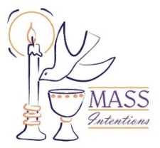
We welcome request for Mass Intentions
You can remember someone who has died recently or many years ago. But the intentions do not have to be just for the dead. They make beautiful gifts for any special occasion: birthdays, anniversaries, or even in thanksgiving. Mass intentions can be made by contacting the parish office or you may drop the following form along with payment in an envelope mark “Mass Intention” in the collection basket. Intentions are $10 per mass.
Dates are filling up so please get your Mass Intentions in to receive your special dates of your loved ones.

For: ___________________________________
Date requested: __________________________
Requested by: ___________________________
Phone Number: __________________________

February 6: 9:30 a.m.
LECTOR: Sue Potthast
MINISTER OF HOLY COMMUNION: Cindy Gnaedinger
GIFT BEARERS: Virginia & Jim Jansen
SERVERS: PSR class
USHERS: Alvin Huels and Craig Diekemper
MUSCIAN: Chad Schrage

January 9: 9:30 a.m.
LECTOR: Jackie Albers
MINISTER OF HOLY COMMUNION: Joe Luebbers
GIFT BEARER: Arlene Hilmes Family
SERVERS: PSR students
USHERS: Alan Heldorfer and Norb Rakers
MUSCIAN: Lisa McQuade

We welcome request for Mass Intentions
You can remember someone who has died recently or many years ago. But the intentions do not have to be just for the dead. They make beautiful gifts for any special occasion: birthdays, anniversaries, or even in thanksgiving. Mass intentions can be made by contacting the parish office or you may drop the following form along with payment in an envelope mark “Mass Intention” in the collection basket. Intentions are $10 per mass.
Most dates are open in 2022!!

For: ___________________________________
Date requested: __________________________
Requested by: ___________________________
Phone Number: __________________________

St. Rose Parish is having a Mission called “Come Back to Me with All Your Hearts”
and would like St. Felicitas Church to join in for an enjoyable, enlightening and will help to renew our Cathholic faith. Each evening will empower us to reconnect with our fellow parish community. All family members are welcome and encouraged to attend any or all the evenings. A social gathering will be held in the cafeteria following each service. Child care is provided (call Carolyn Alberternst at 618-210-4049 and it’s free). Speaker will be Redemptorist Father Peter Schavitz who is an excellent speaker. For more information, go to www.strosechurchil.org and pick up a brochure on table in back of church. Please let Barry or Deb know if you would like to attend.

JANUARY 2: 9:30 a.m.
LECTOR: Ann Hampel
MINISTER OF HOLY COMMUNION: Cindy Gnaedinger
GIFT BEARERS: volunteers
SERVERS: volunteers
USHERS: Barry Hampel and Vince Langenhorst
MUSCIAN: Chad Schrage

December 26: 9:30 a.m.
LECTORS: Millie Peppenhorst
MINISTERS OF HOLY COMMUNION: Joe Luebbers
GIFT BEARERS: Rakers family
SERVERS: volunteers
USHERS: Dan Potthast & John Hampel
MUSCIAN: Lisa McQuade

December 19: 9:30 a.m.

If you would like to be recognized for your birthday or anniversary in the weekly bulletin, please mark your special day in the calendar in the back of church

Volunteers are needed for the Annual Diocesan Christmas Dinner which will be held on Christmas Day. If interested, please see the Dec 5: 9:30 a.m.
LECTORS: Sue Potthast
MINISTERS OF HOLY COMMUNION: Cindy Gnaedinger
GIFT BEARERS: Kathy & Mary Gress
SERVERS: PSR Class
MUSICIAN: Chad Schrage

bulletin board for additional information.

December 12: 9:30 a.m.
LECTORS: Alayna Benhoff
MINISTERS OF HOLY COMMUNION: Jackie Albers
GIFT BEARERS: volunteers
SERVERS: PSR class
MUSICIAN: Lisa McQuade
USHERS: Alvin Huels & Dan Ketterer

November 21: 9:30
LECTORS: Jackie Albers
MINISTERS OF HOLY COMMUNION: Cindy Gnaedinger
GIFT BEARERS: Vince & Connie Barciszewski
SERVERS: PSR Class
MUSICIAN: Maribeth Detmer

November 28: 9:30 a.m.
LECTORS: Sharon Bickl
MINISTERS OF HOLY COMMUNION: Joe Luebbers
GIFT BEARERS: Potthast or Hampel family
SERVERS: volunteers
MUSICIAN: Maryibeth Detmer

This Photo by Unknown Author is licensed under CC BY-NC-ND

Please Update your contact information
Are your records current? Have you dropped your landline or changed your cell number? Have you moved, been married, divorced or had a baby? Please help us keep our records accurate. Please check the folder on the back table and let us know at the parish office by emailing: stfelbp@wisperhome.com. or drop an envelope in the collection basket with your correct information

Oblates Exhibit area at the Shrine of Our Lady of the Snows from November 19th thru December 31. This is also a great opportunity for youth service hours. If interested, please
email programs@snows.org or call 618-394-6281 snows,org/wol

- With whom will I stand in faith?
- How will I keep my eyes fixed on Jesus this day?
Fliers for the upcoming chicken dinner, which is, are available in the back of church.
Please take some and help spread the word.
Worklist and raffle tickets are also available,
please pick up your copy to help save with postage cost.
Also, please start saving your empty ice cream,
margarine, etc containers to use for leftover food.

Please pray for those who need the Lord’s healing in body, mind or spirit, especially Florence Huelsmann, Margie McQuade, Ramona Haislar, Taylor Marti, Gerald Hilmes, Ken Wellen,, Jim Jansen

Please Update your contact information
Are your records current? Have you dropped your landline or changed your cell number? Have you moved, been married, divorced or had a baby? Please help us keep our records accurate. Please check the folder on the back table and let us know at the parish office by emailing: stfelicitasbeaverprairie@gmail.com.

Please Update your contact information
Are your records current? Have you dropped your landline or changed your cell number? Have you moved, been married, divorced or had a baby? Please help us keep our records accurate. Please check the folder on the back table and let us know at the parish office by emailing: stfelbp@wisperhome.com. or drop an envelope in the collection basket with your correct information.

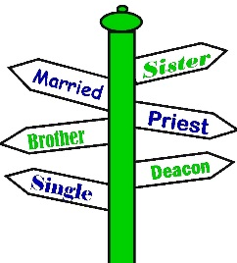

We welcome request for Mass Intentions
You can remember someone who has died recently or many years ago. But the intentions do not have to be just for the dead. They make beautiful gifts for any special occasion: birthdays, anniversaries, or even in thanksgiving. Mass intentions can be made by contacting the parish office or you may drop the following form along with payment in an envelope mark “Mass Intention” in the collection basket. Intentions are $10 per mass.
Available upcoming dates: Sept. 29; Oct. 6, 13 & 27

For: ___________________________________
Date requested: __________________________
Requested by: ___________________________
Phone Number: __________________________
If you have something you would like posted in the bulletin, please have it to the church office by Wednesday evening
via email to: stfelbp@wisperhome.com
or test Lisa by noon on Thursday

.

FATHER BRETT

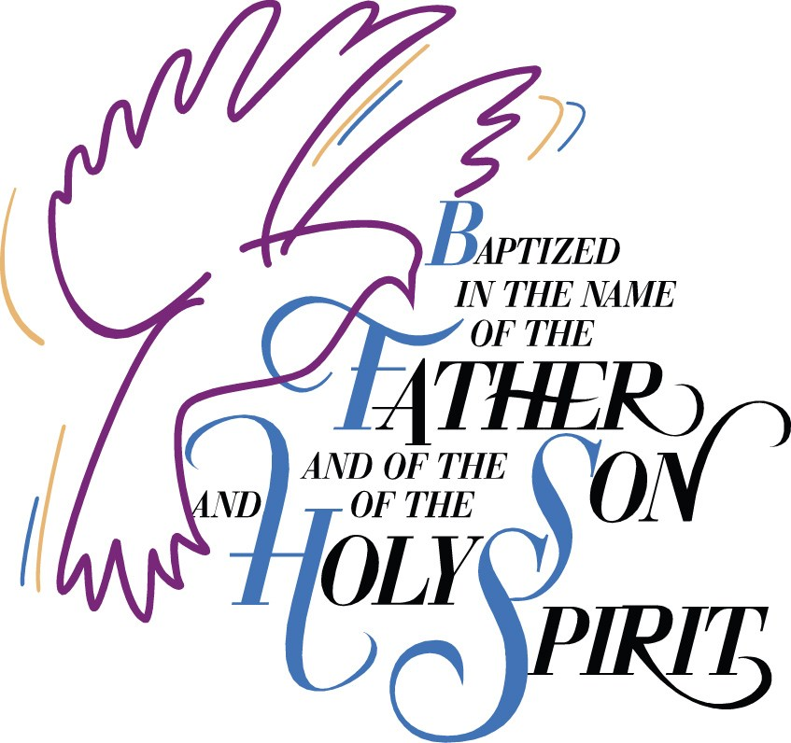

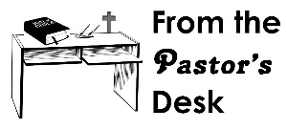

September 5: 9:30am
LECTORS: Millie Peppenhorst
MINISTERS OF HOLY COMMUNION: Lisa Voss
GIFT BEARERS: Monken’s family
SERVERS: Abby, Alex, Alayna, Mariah & Makenna
MUSICIAN: Lisa McQuade

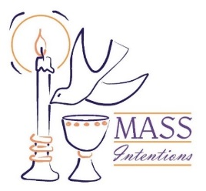
We welcome request for Mass Intentions
You can remember someone who has died recently or many years ago. But the intentions do not have to be just for the dead. They make beautiful gifts for any special occasion: birthdays, anniversaries, or even in thanksgiving. Mass intentions can be made by contacting the parish office or you may drop the following form along with payment in an envelope mark “Mass Intention” in the collection basket. Intentions are $10 per mass.

For: ___________________________________
Date requested: __________________________
Requested by: ___________________________
Phone Number: __________________________

