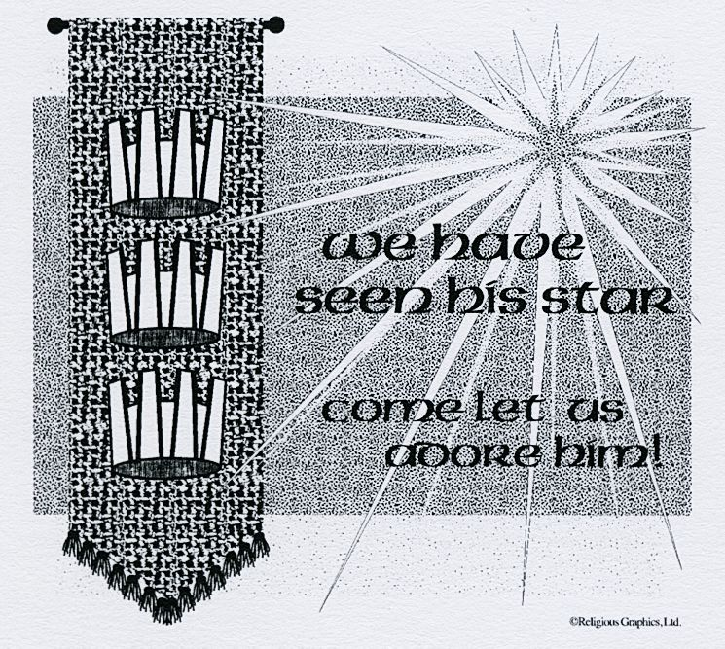
ST. ROSE CHURCH St. Rose, IIlinois
Fr. Edward F. Schaefer
18010 St. Rose Road
526-4118 Rectory

SUNDAY MASS 10:00AM
SAT. VIGIL MASS 4:00PM
WEEKDAY MASS 7:45AM
RECONCILIATION Saturday: 3:15 – 3:45PM
WEBPAGE: www.strosechurchil.com
EMAIL: belpsros@outlook.com
FACEBOOK: St. Rose Catholic Church – St. Rose, IL

MASS WILL BE LIVE STREAMED ON OUR FACEBOOK PAGE SATURDAYS AT 4PM

SUNDAY COLLECTIONS: Weekly Envelopes: $ 2,886.00 Immaculate Conception: $40.00 Capital Improvement Fund: $ 1,495.00
Christmas: $275.00 Solemnity of Mary: $798.00 Sister Parish: $ 22.00

INTENTIONS: MASS
Mon 7:45AM The Baptism of The Lord No Mass
Tue 7:45AM Weekday No Mass
Wed 7:45AM Weekday No Mass
Thu 7:45AM Weekday No Mass
Fri 7:45AM St. Hiliary No Mass
Sat 4:00AM Vigil of The Second Sunday in Ordinary Time Rem & Joseph Grapperhaus
“ “ “ “ “ Jerome Rehkemper
“ “ “ “ “ Bernell & Mary Wellen in Thanksgiving
Sun 10:00AM The Second Sunday in Ordinary Time For the Parish

SERVERS: Sat 4PM Kayden Barriger, Lily Butler, Ali Butler, Lane Butler
Sun 10AM Ruby Jansen, Addison Tebbe, Brianna Tebbe, Cole Timmermann

READERS: Sat, 4PM: Mary Lou Voss Sun 10AM: Lisa Baer

EUCHARISTIC MINISTERS: Sat 4PM Nick Wessel Sun 10AM: Cheryl Timmermann

OFFERTORY: Sat 4PM: Grapperhaus, Rehkemper & Wellen Families
Sun 10AM: Nick Timmermann, Jr., Alfred Holtgrave

VOCATION CUP: The next family to receive the Vocation Cup is the Billy Timmermann, III family.

WELCOME: Please welcome Fr. Tom Killean who will be having the 4PM Mass this weekend and Fr. Jack McEvilly who will be having the Sunday 10AM Mass.

“HAVE YOU REMEMBERED ST. ROSE PARISH IN YOUR ESTATE PLANNING?”

SYMPATHY: Our sympathy to the family of Donald McAlister. Donald, who passed away recently, was the brother-in-law of Bob (Linda) Habermehl. May Donald enjoy the reward of eternal life.

SYMPATHY: Our sympathy to the family of Mary Schroer. Mary, who passed away recently, was
the sister of Beth (Marvin) Meier and Barbara (Joyn) Rinderer. May Mary enjoy the reward of eternal life.

CONGRATULATIONS: To Cameron L. Beer and Larissa J. Jacob who were married here last
weekend. Many blessings to them!

HAPPY ANNIVERSARY:
Jan 10 Brett & Jo Lynn Huelsmann ’15 Jan 12 Ronald & Carol Kohlbrecher ‘91

HAPPY BIRTHDAY:
Jan 09 Peyton Markus 14 Jan 11 Pat Rollins Jan 13 Alan Wilke
Jan 10 Steven Kaufman 20 Jan 13 Kalyn Adams Jan 14 Connie Potthast
Jan 10 Kathryn Timmermann Jan 13 Jerome Eilers Jan 15 Matthew D. Benhoff
Jan 11 Marilyn Fuhler Jan 14 Kevin Klostermann Jan 15 Joyce Steinmann
Jan 11 Shirley Langenhorst Jan 13 Brittany Sussen

VOCATIONS CORNER: What a wonderful Gospel account of the Magi traveling to meet the Lord.
They followed the star – their “call” – to come and offer their gifts to the Lord. But the question arises
As to how the Magi noticed a star at night and no one else really did. Perhaps we need to embrace the
“night” , the stillness, to “see and hear” our call. How are we doing in living our call to Holiness – our vocation as a man, a woman or a child; Married or single; priesthood or religious – of being called to something beyond ourselves?

CHRISTMAS DECORATIONS: The Christmas decorations in church will be taken down THIS Sunday, January 8th after the 10AM Mass. ALL help is appreciated.

DO YOU EVER DREAM OF A WORLD WITHOUT HUNGER OR POVERTY?
Would you seriously like to make this world a reality? Consider joining us for a life changing
course on ‘FAITH AND POVERTY: A GLOBAL RESPONSE.” It is co-sponsored by Just Faith
and Catholic Relief Services. This course will meet at Mater Dei High School for 8 sessions on the first and third Thursdays of each month beginning on Thursday, January 5th from 7 to 9PM.
For questions or to join us, please call Helen Essenpreis (618-980-1875), Fran Etter (618-971-8886) or Myrt Rollins (314-707-7063).
ST. ROSE DEVELOPMENT CLUB MEETING: Monday, January 9th at 8PM in the Development Club.
ST. ROSE SENIOR CARD PARTY: Wednesday, January 11th in the Development Club at 1PM.

ST. ROSE YOUTH LEAGUE DIRVE-THRU BREAKFAST: Sunday, Jan 15th from 7:30AM -11:30AM at the
St. Rose Development Club. Five pound bags of fresh, whole hog pork sausage links will be for sale.
All proceeds will benefit the St. Rose Youth League activities. Adult Plates are $12 and kid’s plates are $6.

TEC #269 WEEKEND: It’s not too late to sign up for TEC Weekend on Jan 14-16 in Columbia IL. Sign up at bellevilletec.org or contact bellevilletec@gmail.com for more information.

CATHOLIC HOLY FAMILY EUCHRE TOURNAMENT: Sunday, Feb 12th at the St. Rose Development Club beginning at 1PM. CHF will match all proceeds and the proceeds will benefit the St. Rose PSR Program.

