St. Felicitas Church
PRAYER REQUEST
Please pray for those who need the Lord healing in body, mind or spirit, especially Florence Huelsmann, Margie McQuade, Taylor Marti, Gerald Hilmes, Ken Wellen,
Jim Jansen, Ed McQuade, Sr. Diane and all who asked for our prayers.
and all who asked for our prayers.
Fr. Dale Maxfield, and all who asked for our prayers.

13322 Church Road
Carlyle, IL 62231
Phone: 594-3040 Fax: 594-3040
stfelbp@wisperhome.com

Father Ed Schaefer
belpsros@outlook.com
Cell: 618-526-4118

Father Tom Killeen

Parish Pastoral Council: Justin Benhoff, Gene Bickl, Cindy Gnaedinger, Joe Luebbers
Finance Council: Mary Huelsmann, John Ketterer, Dan Potthast, Allen Thole and Margie McQuade.
Parish Trustees: Barry Hampel and Alan Heldorfer
Administrative Asst: Deb Rakers 618-698-9141 or 618-594-3040

Third Sunday in Ordinary Time
We gather together today to worship the Lord, as faithful people have done throughout history. Two noteworthy examples are described in our readings. When Ezra the priest read the Torah in the streets of Jerusalem after the Jewish people had returned from exile, it brought people to tears. When Jesus read from the prophets Isaiah in his hometown synagogue, he revealed that he himself was the fulfillment of that passage. As we worship today on this ordinary day in Ordinary Time, let us consider the blessing of being able to listen to the word of God and to partake in this Eucharist feast.
“Today is holy to our Lord,” Ezra proclaimed toward the end of today’s first reading, for the people were able to gather to worship for the first time in over fifty years. What joy it must have inspired! In the Gospel, Jesus announces that the prophecies of glad tidings to the poor, liberty to captives, and freedom for the oppressed are fulfilled in his presence. What an astonishing claim! Let us listen to scripture, realizing that we are inheritors of this profound legacy of God’s word.

Question of the Week

In what ways am I poor, oppressed or held captive? How does the Lord’s promise speak to me? How can I bring glad tidings to those who are poor and oppressed?

Sr. Diane was put on Hospice due to her breathing difficulties. Please keep her in your prayers. Her address is Veronica House, 12284 DePaul Drive, Bridgeton, Mo.
63044. She would love receiving cards.

Knights of Columbus will pass out roses after Mass to promote the life of an unborn.

WEEKLY OFFERING

01-16-22
Envelopes 29
Envelopes Total……….$1245.00
Lose Collection……………$64.00
Grand Total……………$1309.00

Our monthly income for December 2021 was 6964.00 and our monthly expenses totaled $7046.00. Please give as you are able.

Thank you for your generosity!

JANUARY 23: 9:30 a.m.
LECTOR: Alayna Benhoff
MINISTER OF HOLY COMMUNION: Cindy Gnaedinger
GIFT BEARERS: Gress family
SERVERS: PSR class
USHERS: Alvin Huels and Craig Diekemper
MUSCIAN: Lisa Mcquade

JANUARY 30: 9:30 a.m.
LECTOR: Jackie Albers
MINISTER OF HOLY COMMUNION: Lisa Voss
GIFT BEARERS: volunteer
SERVERS: PSR students
USHERS: Barry & John Hampel
MUSCIAN: Maribeth Detmer
\

January 23: pray for a mild winter

January 30

Aiden Voss – January 29

___________________________________________

VOCATION CORNERS
January 23 – My parents gave me and my siblings a joyful and loving childhood where the beauty of the Catholic faith shone brightly. They sent us to a school in Madrid operated by the sisters of the Company of the Savior, whose chrism is to cooperate with parents by providing a strong education in a faithful catholic environment. The joy, devotion and dedication of the sisters immediately attracted me. During my last years of high school and my first year of college, I was tempted by new experiences and friendships based on different ideals than those of my youth. It was Mary who opened my eyes to see deeper. She brought me back to the heart of Jesus. Eventually, I embraced His loving call to be only his and joined the Sisters of the Company of the Savior.
Sr. Maria Alguacil; Sister of the Company of the Savior; Columbia, Sept. 2021

The Messenger Newspaper Subscription Renewal Weekend is Feb. 5-6. With your subscription The Messenger can reach more Catholic in southern Illinois, bring you articles from prominent thinkers and local news all designed to give you new insights and hope.
www.bellevillemessenger.org

Society of St. Vincent De Paul Needs Your Help.
Please see the bulletin board with supplies and food needed if you can help.

St. Rose Parish is having a Mission called “Come Back to Me with All Your Hearts”
and would like St. Felicitas Church to join in for an enjoyable, enlightening and will help to renew our Cathholic faith. Each evening will empower us to reconnect with our fellow parish community. All family members are welcome and encouraged to attend any or all the evenings. A social gathering will be held in the cafeteria following each service. Child care is provided (call Carolyn Alberternst at 618-210-4049 and it’s free). Speaker will be Redemptorist Father Peter Schavitz who is an excellent speaker. For more information, go to www.strosechurchil.org and pick up a brochure on table in back of church. Please let Barry or Deb know if you would like to attend.
_______________________________________

At Sister Thea Catholic School – the only remaining Catholic elementary school in East St. Louis – 100% of the students gtaduate from high school and95% enroll in colleges and universities, trade school and the military! Your support of The Catholic Service and Ministry Appeal helps to make this possible. If you have not already done so, please consider making a gift today. The youngsters at Sister Thea Bowman are counting on you.

JOB OPENINGS
Director of the Respect Life Apostolate: The Diocese of Belleville is seeking a part-time (20 hours per week) to educate Catholic on the issues surrounding the Catholic Church’s teachings regarding the dignity of the human person and sanctity of human life. The Director provides leadership for the RLA and works towards collaboration among offices and agencies within Curia. Additional information is on the bulletin board with how to apply if interested.

Please Update your contact information
Are your records current? Have you dropped your landline or changed your cell number? Have you moved, been married, divorced, or had a baby? Please help us keep our records up to date. Please take a form on table in back if your information has changed.

Hispanic Minister - If interested, please see the qualifications and application deadline on the bulletin board.

Director of the Respect Life Apostolate – The Diocese of Belleville is seeking a part-time (20 hours per week) to educate Catholics on the issues surrounding the Catholic Church’s teaching regarding the dignity of the human person and sanctity of human life. The Director provides leadership for the RLA and works towards collaboration among offices and agencies within the Curia. Additional information is on bulletin board with directions how to apply, but application deadline is Febuary 11, 2022.
___________

January 9: 9:30 a.m.
LECTOR: Jackie Albers
MINISTER OF HOLY COMMUNION: Joe Luebbers
GIFT BEARER: Arlene Hilmes Family
SERVERS: PSR students
USHERS: Alan Heldorfer and Norb Rakers
MUSCIAN: Lisa McQuade

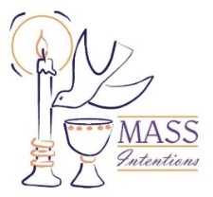
We welcome request for Mass Intentions
You can remember someone who has died recently or many years ago. But the intentions do not have to be just for the dead. They make beautiful gifts for any special occasion: birthdays, anniversaries, or even in thanksgiving. Mass intentions can be made by contacting the parish office or you may drop the following form along with payment in an envelope mark “Mass Intention” in the collection basket. Intentions are $10 per mass.
Most dates are open in 2022!!

For: ___________________________________
Date requested: __________________________
Requested by: ___________________________
Phone Number: __________________________

JANUARY 2: 9:30 a.m.
LECTOR: Ann Hampel
MINISTER OF HOLY COMMUNION: Cindy Gnaedinger
GIFT BEARERS: volunteers
SERVERS: volunteers
USHERS: Barry Hampel and Vince Langenhorst
MUSCIAN: Chad Schrage

December 26: 9:30 a.m.
LECTORS: Millie Peppenhorst
MINISTERS OF HOLY COMMUNION: Joe Luebbers
GIFT BEARERS: Rakers family
SERVERS: volunteers
USHERS: Dan Potthast & John Hampel
MUSCIAN: Lisa McQuade

December 19: 9:30 a.m.
LECTORS: Ann Hampel
MINISTERS OF HOLY COMMUNION: Lisa Voss
GIFT BEARERS: Alvin & Mary Huels Family
SERVERS: PSR Class
MUSICIAN: Maribeth Detmer
USHERS: Craig Diekemper & Vince Langenhorst

If you would like to be recognized for your birthday or anniversary in the weekly bulletin, please mark your special day in the calendar in the back of church

Volunteers are needed for the Annual Diocesan Christmas Dinner which will be held on Christmas Day. If interested, please see the Dec 5: 9:30 a.m.
LECTORS: Sue Potthast
MINISTERS OF HOLY COMMUNION: Cindy Gnaedinger
GIFT BEARERS: Kathy & Mary Gress
SERVERS: PSR Class
MUSICIAN: Chad Schrage

bulletin board for additional information.

December 12: 9:30 a.m.
LECTORS: Alayna Benhoff
MINISTERS OF HOLY COMMUNION: Jackie Albers
GIFT BEARERS: volunteers
SERVERS: PSR class
MUSICIAN: Lisa McQuade
USHERS: Alvin Huels & Dan Ketterer

November 21: 9:30
LECTORS: Jackie Albers
MINISTERS OF HOLY COMMUNION: Cindy Gnaedinger
GIFT BEARERS: Vince & Connie Barciszewski
SERVERS: PSR Class
MUSICIAN: Maribeth Detmer

November 28: 9:30 a.m.
LECTORS: Sharon Bickl
MINISTERS OF HOLY COMMUNION: Joe Luebbers
GIFT BEARERS: Potthast or Hampel family
SERVERS: volunteers
MUSICIAN: Maryibeth Detmer

This Photo by Unknown Author is licensed under CC BY-NC-ND

Please Update your contact information
Are your records current? Have you dropped your landline or changed your cell number? Have you moved, been married, divorced or had a baby? Please help us keep our records accurate. Please check the folder on the back table and let us know at the parish office by emailing: stfelbp@wisperhome.com. or drop an envelope in the collection basket with your correct information

Oblates Exhibit area at the Shrine of Our Lady of the Snows from November 19th thru December 31. This is also a great opportunity for youth service hours. If interested, please
email programs@snows.org or call 618-394-6281 snows,org/wol

- With whom will I stand in faith?
- How will I keep my eyes fixed on Jesus this day?
Fliers for the upcoming chicken dinner, which is, are available in the back of church.
Please take some and help spread the word.
Worklist and raffle tickets are also available,
please pick up your copy to help save with postage cost.
Also, please start saving your empty ice cream,
margarine, etc containers to use for leftover food.

Please pray for those who need the Lord’s healing in body, mind or spirit, especially Florence Huelsmann, Margie McQuade, Ramona Haislar, Taylor Marti, Gerald Hilmes, Ken Wellen,, Jim Jansen

Please Update your contact information
Are your records current? Have you dropped your landline or changed your cell number? Have you moved, been married, divorced or had a baby? Please help us keep our records accurate. Please check the folder on the back table and let us know at the parish office by emailing: stfelicitasbeaverprairie@gmail.com.

Please Update your contact information
Are your records current? Have you dropped your landline or changed your cell number? Have you moved, been married, divorced or had a baby? Please help us keep our records accurate. Please check the folder on the back table and let us know at the parish office by emailing: stfelbp@wisperhome.com. or drop an envelope in the collection basket with your correct information.

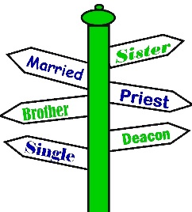

We welcome request for Mass Intentions
You can remember someone who has died recently or many years ago. But the intentions do not have to be just for the dead. They make beautiful gifts for any special occasion: birthdays, anniversaries, or even in thanksgiving. Mass intentions can be made by contacting the parish office or you may drop the following form along with payment in an envelope mark “Mass Intention” in the collection basket. Intentions are $10 per mass.
Available upcoming dates: Sept. 29; Oct. 6, 13 & 27

For: ___________________________________
Date requested: __________________________
Requested by: ___________________________
Phone Number: __________________________
If you have something you would like posted in the bulletin, please have it to the church office by Wednesday evening
via email to: stfelbp@wisperhome.com
or test Lisa by noon on Thursday

.

FATHER BRETT

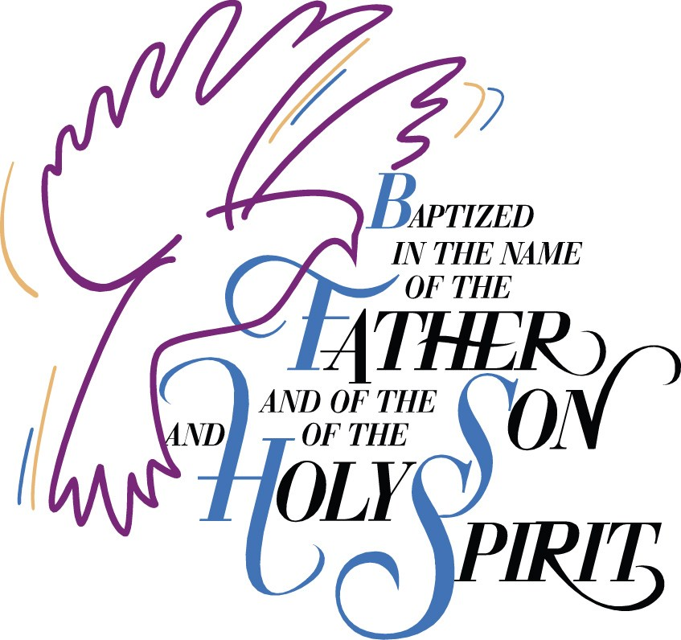

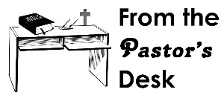

September 5: 9:30am
LECTORS: Millie Peppenhorst
MINISTERS OF HOLY COMMUNION: Lisa Voss
GIFT BEARERS: Monken’s family
SERVERS: Abby, Alex, Alayna, Mariah & Makenna
MUSICIAN: Lisa McQuade

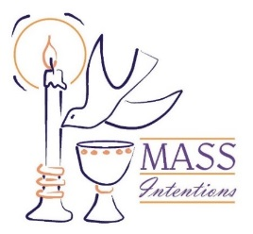
We welcome request for Mass Intentions
You can remember someone who has died recently or many years ago. But the intentions do not have to be just for the dead. They make beautiful gifts for any special occasion: birthdays, anniversaries, or even in thanksgiving. Mass intentions can be made by contacting the parish office or you may drop the following form along with payment in an envelope mark “Mass Intention” in the collection basket. Intentions are $10 per mass.

For: ___________________________________
Date requested: __________________________
Requested by: ___________________________
Phone Number: __________________________

