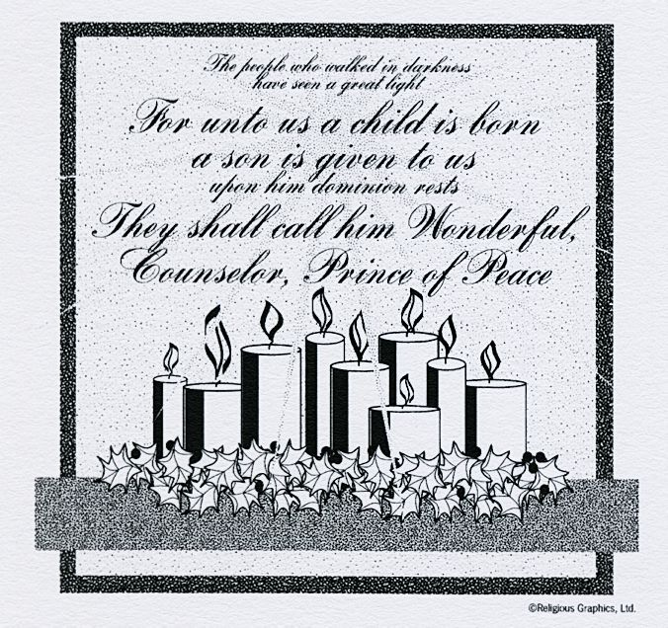
ST. ROSE CHURCH St. Rose, IIlinois
Fr. Edward F. Schaefer
18010 St. Rose Road
526-4118 Rectory

SUNDAY MASS 10:00AM
SAT. VIGIL MASS 4:00PM
WEEKDAY MASS 7:45AM
RECONCILIATION Saturday: 3:15 – 3:45PM
WEBPAGE: www.strosechurchil.com
EMAIL: belpsros@outlook.com
FACEBOOK: St. Rose Catholic Church – St. Rose, IL

MASS WILL BE LIVE STREAMED ON OUR FACEBOOK PAGE SATURDAYS AT 4PM

SUNDAY COLLECTIONS: Weekly Envelopes: $ 5,092.00
Immaculate Conception: $25.00 Capital Improvement Fund: $10,415.00
Religious Retirement: $150.00 Sister Parish: $ 5.00
Christmas: $ 280.00

INTENTIONS: MASS
Mon 7:45AM St. Stephen No Mass
Tue 7:45AM St. John No Mass
Wed 7:45AM The Holy Innocents No Mass
Thu 7:45AM St. Thomas Becket No Mass
Fri 7:45AM Holy Family of Jesus, Mary & Joseph No Mass
Sat 4:00AM Vigil of the Solemnity of Mary For the Parish
Sun 10:00AM Solemnity of Mary JoAnn Vonder Haar
“ “ James Fuhler
“ “ Joe Fischer

SERVERS: Sat 4PM Ryan Segert, Landon Tebbe, Alaina Schrage, Kayden Barringer
Sun 10AM Caitlyn & Lauryn Vonder Haar, Briggs & Wade Kramer

READERS: Sat, 4PM: Jeff Kampwerth Sun 10AM: Pam Andrews

EUCHARISTIC MINISTERS: Sat 4PM Mary Jean Harper Sun 10AM: Bev Kapp

OFFERTORY: Sat 4PM: Mike Timmermann & Ralph Tebbe
Sun 10AM: Vonder Haar, Fuhler & Fischer Families

VOCATION CUP: The next person to receive the Vocation Cup is Steve Thole.

WELCOME: Please welcome Fr. Ed who will be having the 4PM Mass this weekend and Deacon Art
Hampton who will be assisting and Fr. Benny George who will be having the Sunday 10AM Mass.

“HAVE YOU REMEMBERED ST. ROSE PARISH IN YOUR ESTATE PLANNING?”

CONGRATULATIONS: To Seth Allen Schulte who was Baptized here last weekend. Seth is the
Son of Todd and Rhonda (Mettler) Schulte. Many blessings to him!

HAPPY ANNIVERSARY:
Dec 29 Craig & Emily Gnaedinger ’12 Dec 31 Colby & Danielle Voss ‘18

HAPPY BIRTHDAY:
Dec 26 Nicole Hempen 20 Dec 29 Citlyn Willis Dec 30 Sandra Timmermann
Dec 26 Phillip Rund Dec 30 Anna Alberternst Dec 30 Elaine Voss
Dec 26 Evan Schuette Dec 30 Kenadi Barringer 20 Dec 31 Alicia Eversgerd
Dec 27 Jeralyn Becker Dec 30 Tom Harper, II Dec 31 Reagan Lohman 2
Dec 28 Duane Poettker Dec 30 Lillian Hilmes 9 Jan 01 Luke Fuhler
Dec 28 William Timmermann IV 10 Dec 30 Adam Kampwerth Jan 01 Patricia Poettker
Dec 28 Kenneth Wilke Dec 30 Beth Meier
Dec 29 Tori Koch Dec 30 Dennis Schumacher
Dec 29 Marvin Meier Dec 30 Briana Tebbe

VOCATIONS CORNER: Today we celebrate the Birth of our Lord. Our God coming to earth takes on our human nature. He entered a human family – a couple who each had said “YES” to becoming the parents of Jesus. Each of them was called to a unique way to love and serve their family, but the power of their love within also went out to the world. Can we, as family, support one of our family members who might be discerning a call to the religious life? Joseph and Mary made that ultimate sacrifice.

A CHRISTMAS MESSAGE FROM BISHOP MICHAEL MCGOVERN:
“As we celebrate the Nativity of our Lord, I think of the words St. John wrote in one of his epistles:
“we have come to know and believe in the love God has for us.” My sincere prayer for the people of our diocese is that as we celebrate the birth of our Lord Jesus, each of us comes to know and believe more deeply in the love God has for us. May this Christmas be filled with a spirit of kindness and compassion and may you, your families and loved ones be filled with the peace of Christ in the New Year.”

45TH ANNUAL CHRISTMAS COLLECTION: 100% of the money collected through this fund stays in our diocese. During the past year $143,820 was distributed to those in need through your gifts to the Christmas Collection. This collection will be taken up at the Christmas Masses. Please give as you are able.

DO YOU EVER DREAM OF A WORLD WITHOUT HUNGER OR POVERTY?
Would you seriously like to make this world a reality? Consider joining us for a life changing
course on ‘FAITH AND POVERTY: A GLOBAL RESPONSE.” It is co-sponsored by Just Faith
and Catholic Relief Services. This course will meet at Mater Dei High School for 8 sessions on the first and third Thursdays of each month beginning on Thursday, January 5th from 7 to 9PM.
For questions or to join us, please call Helen Essenpreis (618-980-1875), Fran Etter (618-971-8886) or Myrt Rollins (314-707-7063).
A MESSAGE FROM Bishop McGovern & THE MINISTRIES & PROGRAMS FUNDED BY CSMA:
The true joy of Christmas is in the everlasting love of Christ. May you find His peace, love and joy now
and in the coming New Year. With deepest gratitude for your prayers and generosity.

HAPPY BIRTHDAY BABY JESUS!
MERRY CHRISTMAS!

