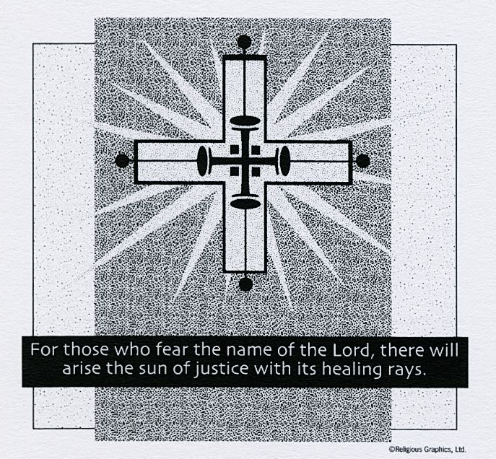
ST. ROSE CHURCH St. Rose, IIlinois
Fr. Edward F. Schaefer
18010 St. Rose Road
526-4118 Rectory

SUNDAY MASS 10:00AM
SAT. VIGIL MASS 4:00PM
WEEKDAY MASS 7:45AM
RECONCILIATION Saturday: 3:15 – 3:45PM
WEBPAGE: www.strosechurchil.com
EMAIL: belpsros@outlook.com
FACEBOOK: St. Rose Catholic Church – St. Rose, IL

MASS WILL BE LIVE STREAMED ON OUR FACEBOOK PAGE SATURDAYS AT 4PM

SUNDAY COLLECTIONS: Weekly Envelopes: $3,756.00
All Saints: $120.00 Capital Improvement Fund: $1,285.00
Sister Parish: $86.00 Thanksgiving: $ 70.00 Assumption: $ 40.00
INTENTIONS: MASS
Mon 7:45AM Weekday No Mass
Tue 7:45AM St. Albert the Great No Mass
Wed 7:45AM St. Margaret of Scotland & St. Gertrude No Mass
Thu 7:45AM St. Elizabeth of Hungary No Mass
Fri 7:45AM Weekday No Mass
Sat 4:00PM Our Lord Jesus Christ, King of the Universe For the Parish
Sun 10:00AM Our Lord Jesus Christ, King of the Universe Andy Jansen
“ “ “ “ “ “ “ “ Joe Fischer
“ “ “ “ “ “ “ “ Herman & Helen Timmermann

SERVERS: Sat 4PM Mandy Poettker, Peyton Markus, Ava Tischer, Alaina Schrage
Sun 10AM Jayce, Emily, Mabry, Will

READERS: Sat 4PM Jeff Kampwerth Sun 10AM: CYM

EUCHARISTIC MINISTERS: Sat 4PM Melanie Rund Sun 10AM: Avery

OFFERTORY: Sat 4PM: Kohlbrecher & Schrage Family Sun 10AM: Dane & Cora

VOCATION CUP: The next family to receive the Vocation Cup is the Norbert Thole family.

WELCOME: Please welcome back Fr. Benny George who will be having the Masses this weekend.

UPDATE: Please continue to keep Fr. Ed in your prayers as he recovers. If you would like to send Fr. Ed well wishes, please drop it in the collection basket or send to Hincke Home, 2620 Lebanon Ave, Belleville, IL 62221. He continues to make progress in his healing and strength.

“HAVE YOU REMEMBERED ST. ROSE PARISH IN YOUR ESTATE PLANNING?”

SYMPATHY: Our sympathy to the family of Carol Frey. Carol, who passed away recently was the sister of Mary Lou (Virgil) Voss and the aunt of Rebecca (Dave) Boeschen and Ben (Nancy) Voss and the great-aunt of Grace Boeschen. May Carol enjoy the reward of eternal life.

HAPPY ANNIVERSARY:
Nov 14 Derek & Megan Frey ’20 Nov 15 Mark & Sherry Rehkemper ‘74
HAPPY BIRTHDAY:
Nov14 Greg Jeckstadt Nov 17 Wyatt Huelsmann 7 Nov 19 Rebecca Boeschen
Nov 15 Helen Detmer Nov 17 Megan Thole Nov 19 Maryn Heinzmann 2
Nov 15 Randy Fuhler Nov 18 Callie Buehne 5 Nov 19 Karl Stock
Nov 15 Corynn Henrichs Nov 18 Mike Kaufman Nov 20 Edwina Tebbe
Nov 15 Jason Peters Nov 18 Heather Rehkemper Nov 20 Kammi Tebbe
Nov 16 Christina Gall Nov 18 Rose Rensing Nov 20 Eugene Wilken
Nov 16 Linda Giller Nov 18 Courtney Taylor
Nov 16 Marvin Tebbe Nov 18 Tim Trame

VOCATIONS CORNER: “Discovering vocation does not mean scrambling toward some prize just beyond my reach but accepting the treasure of true self I already possess. Vocation does not come from a voice out there calling me to be something I am not. It comes from a voice in here calling me to be the person I was born to be, to fulfill the original selfhood given me at birth by God.” – Thomas Merton
ATTENTION ST. ROSE PARISHIONERS: PLEASE STAY AFTER CHURCH THIS WEEKEND FOR A SPECIAL PRESENTATION OF THE PEOPLE AND PASTOR IN OUR SISTER PARISH IN GUATEMALA BY FRAN & CARLY ETTER WHO VISITED OUR SISTER PARISH OF THE HOLY FAMILY THIS SUMMER! THIS IS YOUR ONLY CHANCE TO CONNECT WITH OUR SISTER PARISH & ITS PEOPLE OF FAITH. DON’T MISS IT! WE WILL MEET AFTER THE 4PM MASS AND THE 10AM MASS IN THE CAFETERIA.
ADVENT RECONCILIATION: St. George, New Baden Wed Nov 16 6PM St. Mary, Carlyle, Sunday, Dec 4th 3PM St. Francis, Aviston, Sunday, Dec 11th 3PM St. Mary, Centralia, Monday, Dec 12th 6PM and Thursday, Dec 15th 12:30PM St. Augustine, Breese, Thursday, Dec 15th 7PM St. Mary, Mt. Vernon, Dec 16 3-9PM
WHEATFIELD TWP FIRE DEPT DRIVE THROUGH CHICKEN DINNER: THIS Sunday, Nov 13th from 11AM to 5PM at St. Felicitas Church Hall in Beaver Prairie. MATER DEI BAND PARENTS CHICKEN DINNER: THIS Sunday, Nov 13th from 3PM to 6PM at the Knights of Columbus Hall in Breese. Carryouts only. ST. ROSE DEVELOPMENT CLUB MEETING: Tuesday, Nov. 14th at 8PM
NORTH CENTRAL VICARIATE CANCER MASS: Tuesday, Nov. 15th at 7PM at St. Boniface, Germantown. Annointing of the sick will be celebrated during the Mass. Prayers to St. Peregrine, patron saint of people with cancer will also be part of the Mass prayers. Families and caregivers welcome. BIBLE STUDY: Taught by Deacon Steve, resumes Nov 23rd 7PM to 8:30PM in the St. Francis Aviston Parish Center Primary Room 2. Books are free to members of our partnership. RSVP 618-228-7936.
CATHOLIC CAMPAIGN FOR HUMAN DEVELOPMENT: Next week our collection will support the CCHD. More than 7 million people in the United States live in poverty. Please give what you can. For more info contact www.usccb.org/cchd

